# THE NOTICE BOARD



**User Manual**

**© 2022 -MUGISA BRIAN - 2000707823 - 20/U/7823/PS**

The Notice Board is an Online Shopping System trusted by thousands of Users, since it allows them to purchase goods online, and add their own items to the market place for sale.

Here is a quick walk through of what The Notice Board really is.

# Table of Contents

Splash Screen

Home Screen

Sign Up (Register) Screen Sign in Screen

Forgot Password Screen Market Place Screen Purchase Item Screen Add Item Screen

**NOTE**

**Zoom In the Pages for a Better and Detailed View of this User Manual**

## Splash Screen

**This is shown to the user, as the system loads resources in the background before it starts**



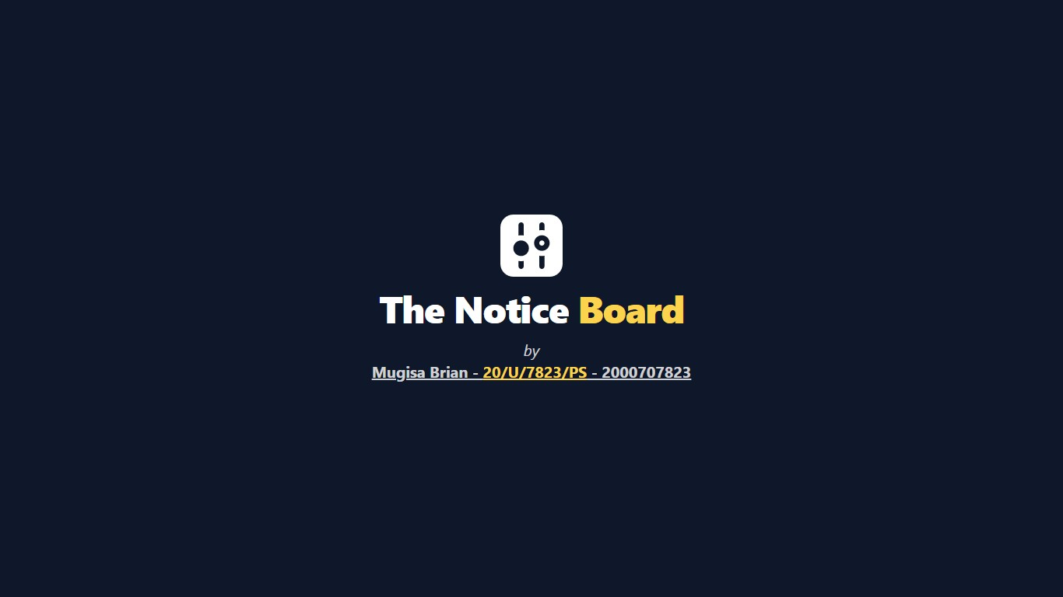

**1**

**2**

© 2022 -MUGISA BRIAN - 2000707823 - 20/U/7823/PS



Welcome Text

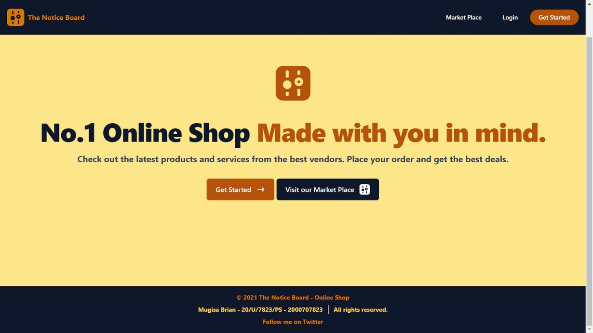

**6**

**Logo**

**4**

**5**

**Login Button**

**3**

**1**

**3**

**4**

**2**

**The Notice Board Footer**

Get started Button

Visit Market Place Button

## Sign Up Screen

**This is allows a user to create an account that will be used by the system for authentication and authorization**

**5 Logo**

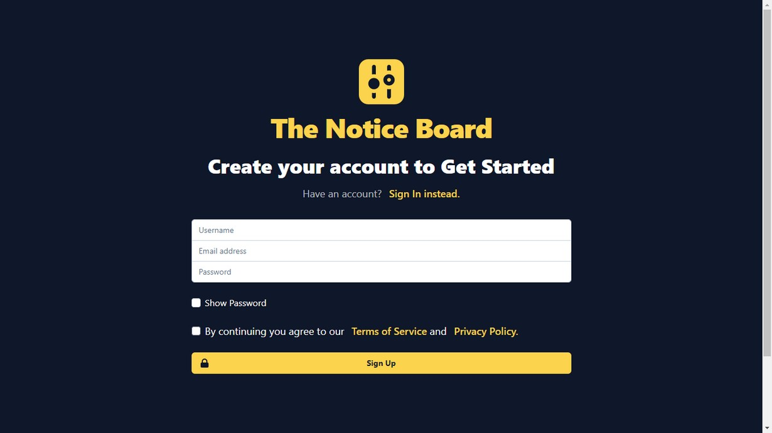

1 Create Account Text

Form to capture user details 4

2 Disclaimer

3 Sign Up Button



**5 Logo**

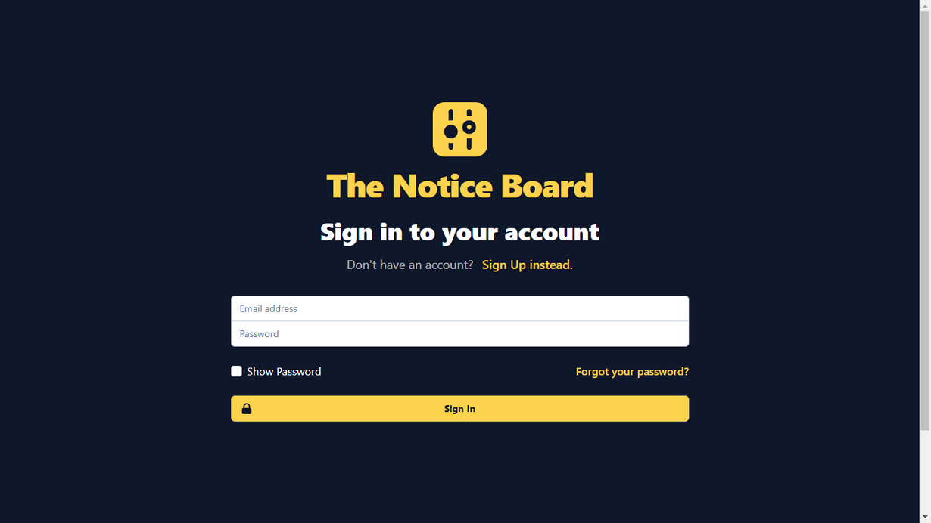

1 Sign In Text

Form to capture user details 4

2 Forgot Password Button

3 Sign in Button



Sympathy text

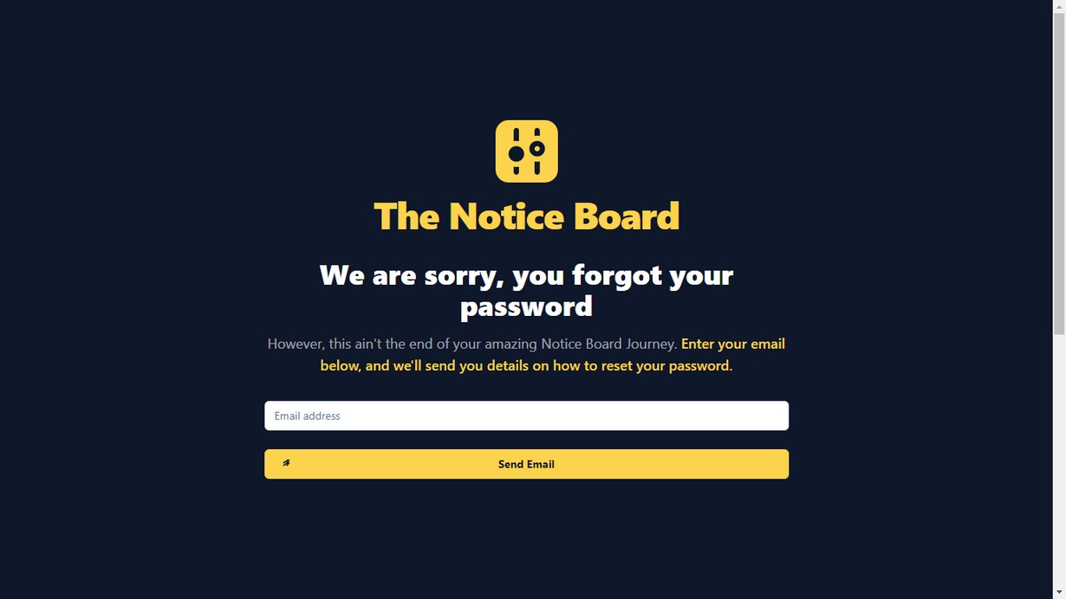

**4**

**Logo**

**1**

**3**

**2 Send Email Button**

Email Capture Field



Back to Home Button 1

Logged In User Details 2

3 Add Item Button

4 Log Out Button

Item Name 6

Item Quantity and Status 7

(In Stock or Out of stock)

**5 Market Item**

Item Price 8

Buy Item Button 9

© 2022 -MUGISA BRIAN - 2000707823 - 20/U/7823/PS

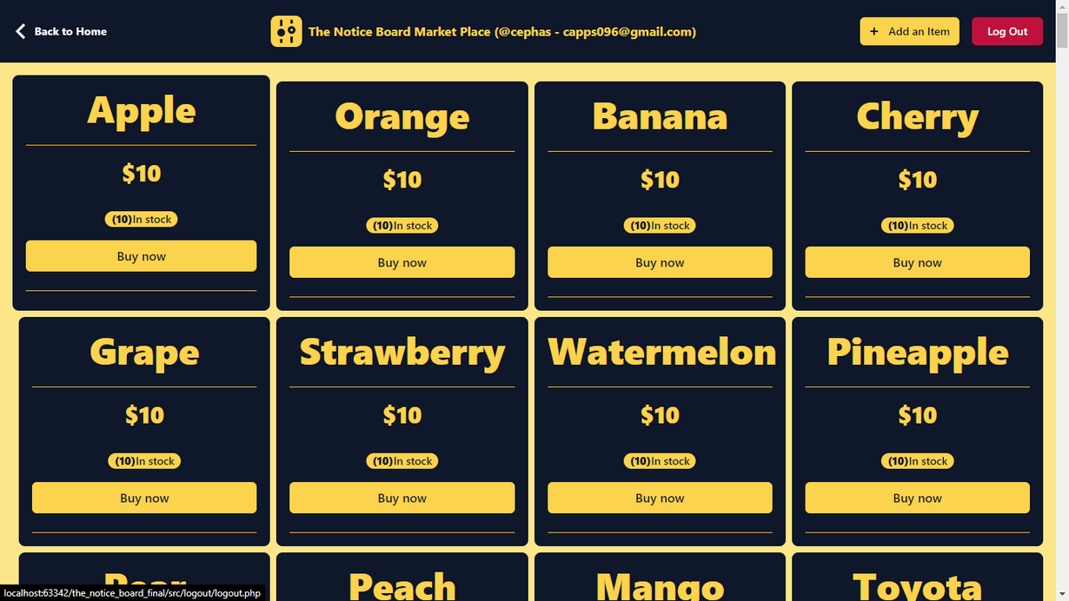

Back to Market place Button 1

Item Name 2

**6 Market Item**

Item Price 3

7 Item Status

(In Stock or Out of stock)

Quantity Left In stock 4

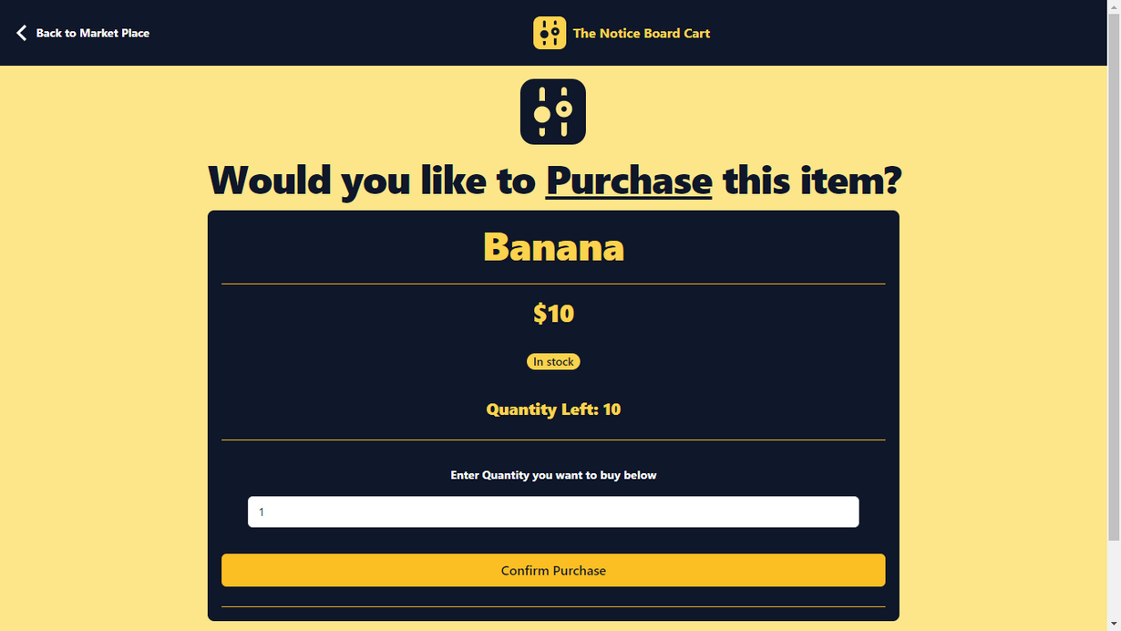

8 Quantity Field

Confirm Purchase Button 5

© 2022 -MUGISA BRIAN - 2000707823 - 20/U/7823/PS

Back to Market place Button 1

2 Logged In User Details

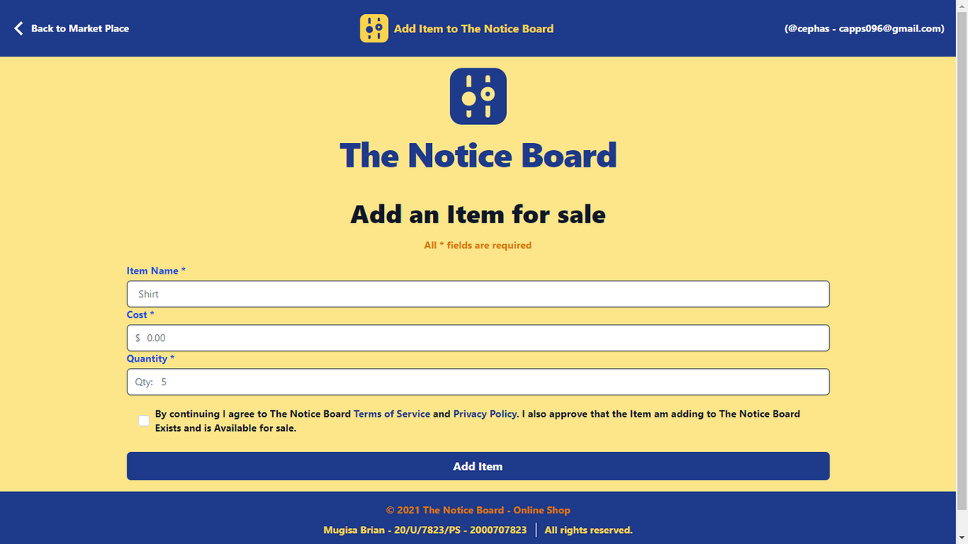

Item Name 3

1. **Item Price**

Item Quantity Field 4

1. **Disclaimer**

Add Item Button 5

6 The Notice Board Footer

# THE NOTICE BOARD



**User Manual**

**© 2022 -MUGISA BRIAN - 2000707823 - 20/U/7823/PS**

The Notice Board is an Online Shopping System trusted by thousands of Users, since it allows them to purchase goods online, and add their own items to the market place for sale.

Here is a quick walk through of what The Notice Board really is.